Child Development

Students Name or Students Names
Department Affiliation or University Affiliation
Course Number: Course Name
Instructors Name
Assignment Due Date

Child Development
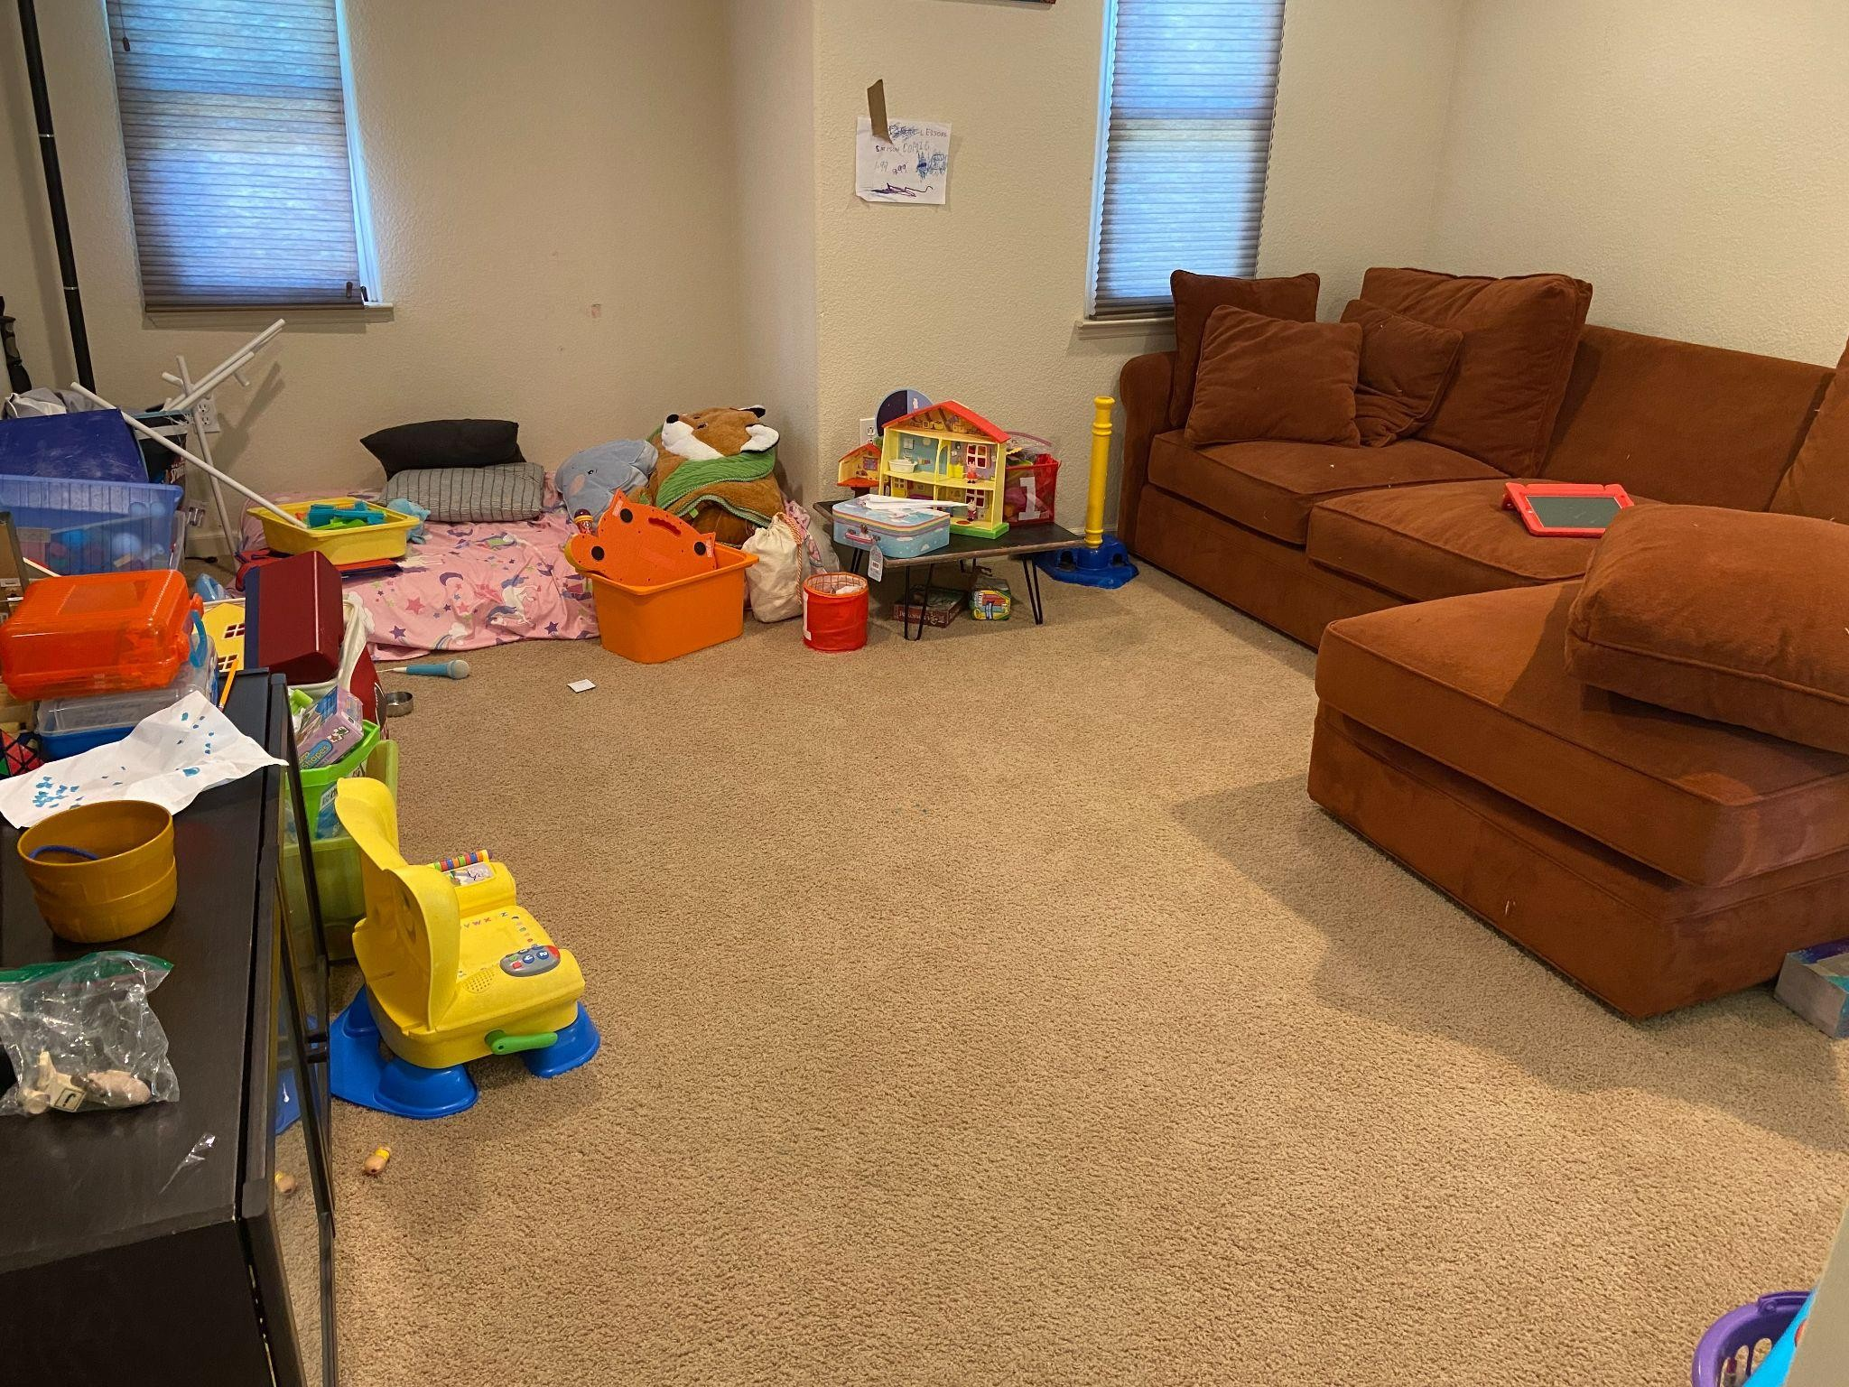

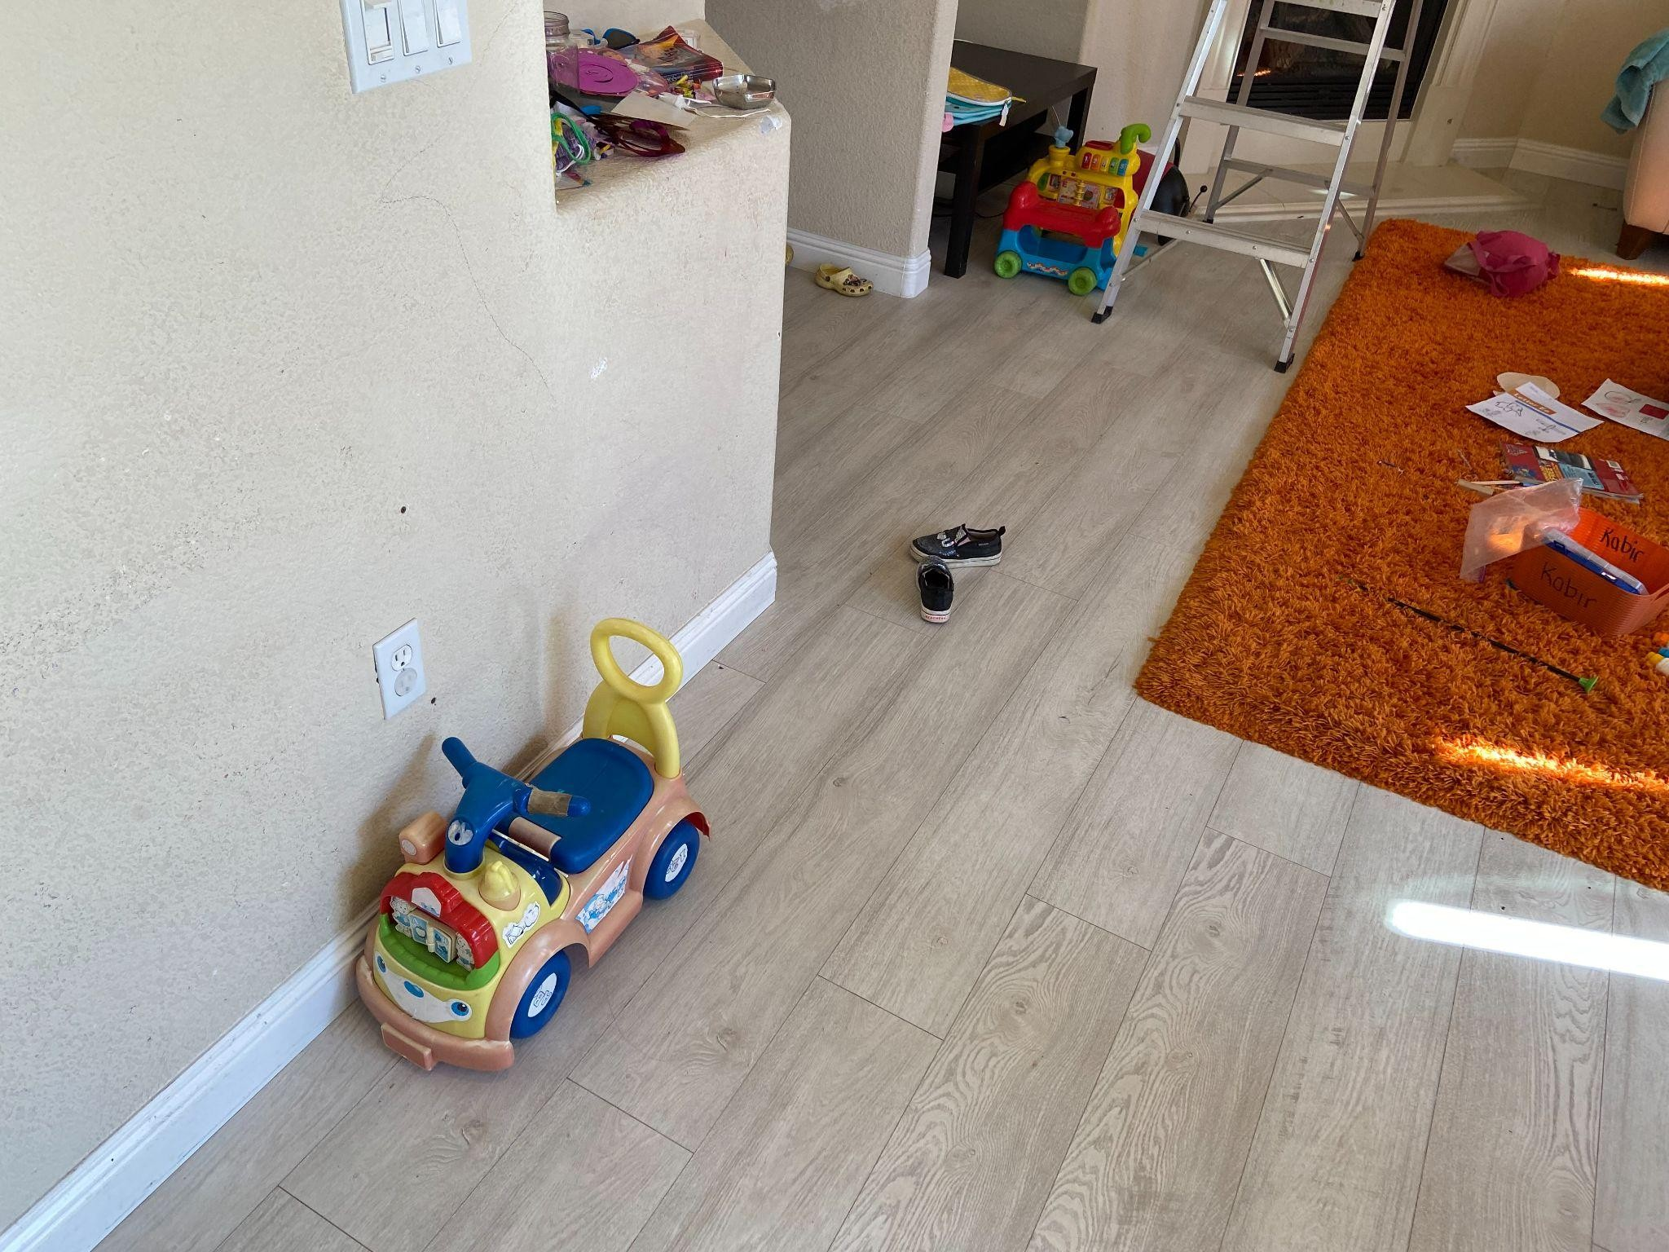
Physical and Motor Development:
Describe what you saw when the child used fine motor skills. The observation examples might include working with small items such as puzzles, pegs, art materials, dressing dolls, scissors, putting on his clothing, buttoning, zipping, washing, drying his hands, and eating.
When they are in reach of a paper and a pen, they tend t draw pictures of the family from the pictures hanging on the wall in the house and scribble anything pictures or weird lines, cartoons, and animals. The child imitates others while driving his toy cars and acts as if they are on a highway and pop their heads outside, insinuating that they are talking with another driver on the road. Equally, the child can try acting like a mechanic repairing the toy cars and adding water in the form of fueling up the car while folding up their sleeves, painting an image of a mechanic as they lace up their shoes tightly even when he is wearing sandals.
Describe the gross motor activities the child was involved in. Give examples of how they walk, jump, skip, climb, riding bikes, etc.
When soccer highlights were put on the television, they tended to imitate the players' celebration mode, even sliding like on the turf respective on the danger they exposed to themselves. The child cannot settle and sit tight instead of jumping on the sofa repeatedly, and even warning to stop is not stopping him from jumping all over the sofa after a few minutes.
Describe the eye-hand coordination activities and the balancing activities you saw the child participating in. Give examples
While playing, the child throws a ball in the air and runs to grab it, lacking a good grip of items, thus falling but with him having a slight touch of the ball (Supriatin et al., 2020). When there is someone else within his view, he tends to throw the ball at you with the expectation of you throwing it back so that they can grab it.
Analysis of physical development:
Using the above observations, analyze if they are on the developmentally right track for their physical development.
How does the child compare in size and weight with the typical development criterion for that age?
The child is growing normally as he does not lock so heavy for the weight and is a little taller than his agemates. Engagement in any activities is as usual as the child's body is relative and allows them to move around easily and even run around the house.
Note the way the child walks. Does the walk seem typical for this age, or is it different?
There is no struggling in walking, and they have the upright walking stature whole walking. However, after some play and engagement in the running, they tend to walk sluggishly while leaning with one side and more swinging while walking, depicting laziness.
How is their gross and fine motor development in comparison to the milestones expected at that age?
A three-year own child is expected to walk by themselves and can take quite a distance by walking by themselves. The child can hold items such as a cup or a plate and feed themselves and go upstairs for a short distance due to getting tired. Like other children, the child can gallop around, walk going behind, and even try balancing using one leg.

Cognitive Development:
What appears to be the theme of their play?
A toddler is expected to be able to remember the games they had been taught by their caregivers as well as those they have seen or if they have had the playing gadgets for a given period. Therefore, the child tends to play the same game frequently and is in love with it as they imitate their surroundings.
What kind of pretend play did you observe? Is this pretend to play simple or complex? Why?
When playing with the toy cars, the child pretends to be a mechanic and even lies under the ground as if they are fixing under the car. It is complex for a child as to how they attach themselves to such and imitate it meaning they have cognition for even difficult things to pick up as a toddler.
Are other children included in their play? Describe the other child’s involvement or role. How does this child interact with the other children? Do they play together? How does peer interaction influence their play or behaviors? Give example
When playing with their cousins, the child engages with them as they ride on each other's back, emulating a horse and take turns on who is carrying the other. The other children seem to enjoy their company as they are all jovial and know that they should be good to their friends, so they get to play next time they are even remorseful when one of the children injures themselves.
Are props used during their play? (Props are toys or objects that children use) Please provide some examples of props that the child uses to extend the play and how they are used.
The child loves cartoons, and his favorite character is spiderman and thus wears a spiderman mask while playing to depict himself as a vigilante trying to help his friends as they throw kicks in the air and as if releasing spider webs to other children.
Describe any interactions between the child and other adults. Do you see these influencing their play? Provide examples of any such dialogue.
The child loves to nutmeg adults using their hands as they throw balls to adults and enjoys the act always. The moment the child interacts with an adult who they had nutmegged before they repeat the action.
Analysis of cognitive development:
Identify the elements in their environment influencing their behaviors? (These can be parents, other adults, siblings, or how the place is set up.)
The caregiver to the toddler will aid in developing their behavior with the interactions they have and telling them when they are wrong and appreciation in the form of applause. The type of toys that the child is bought to play with makes the play and imitate others such as having a ball or a car making them point out at cars whether in the television.
What “stage of play” is the child exhibiting?
The child has associative and projective play as he enjoys playing with other children, likes storytelling, and follows through when reciting short stories.
Is the child cognitively on the right track of development? Explain this using Piaget’s theory of The preoperational stage.
The child is on the right track of cognitive development as they are curious within their environment and with items with constant opening up of items to know what is inside and ability to talk some words clearly (Babakr et al., 2019). The preoperational stage in Piaget's theory acknowledges that children have adopted a symbolic level with limited cognition. The child at times does not play with other children while they are also playing and feels that his play is better than the rest.
Language development
How does the child use language during their play? Is “self-talk” involved? Provide examples of language used in the child’s play.
When the child wants to ask for another child’s toy, he tries to ask for it from the other child and make sounds while playing for imitation. In addition, the child sometimes talks to himself by having a conversation by himself as two characters, especially following videos he has seen and even imitating television advertisements.
Does the teacher/parent ask any questions or make comments during this time? How do they respond to adults? Please provide examples of their conversations.
When the child depicts boredom, it is easier for them to ask for permission to play and thus asks permission from the parent, and they change their intonation and look humble in Infront of an adult. On the other hand, when adults interrupt a child playing, they get angry and lament to the adult with other non-verbal cues to show frustration.

Analysis of language development:
What stage of language development is the child at? How do you know that?
A three-year-old is curious about the environment and thus starts talking to his friends and parents. The child is finishing up on the two-word language development and is beginning to make short sentences with discrepancies in grammar. Finally, the child can talk to an adult, and the adult will get them through their language might be wrong at times.
Social-emotional development:
Describe the feelings that the child expressed during your observation. How did they express those?
The child showed aggressiveness, especially when he felt his peace was being intruded and thus agitated and might start crying immediately. On the other hand, the child shows love by hugging the parent and holding them tightly when they get back home. The child finds joy when playing and when eating food that they enjoy, especially candy and chocolates.
How does the child show affection for another child or adult? Do you see different reactions based on familiarity with other people involved?
When the child is used to either other children or an adult, they show humility through their facial expression when one gets injured while playing and also hugs other children when asked to by the parent as a way of welcoming them to their home or when they are happy and playing around an adult.
Did you see any signs of aggression? Describe if you saw any conflicts and the ways they were resolved
The child has episodes of aggression towards adults, stopping them from whatever they are doing and other children who try taking his toys. His color example, he took his toy from his hands, went ahead, pushed him to his fall, took back his toy, and went ahead with his play.
Do you see any empathy? Did the child help other children?
When another child was crying, he stood and hugged them while wiping their tears as a form of empathy when an adult had shouted at them.
How does the child respond to frustration, such as having to wait for a toy?
The child pouts out of frustration and ends up crying afterward when the frustration continues, especially when caused by another person.
Did the child seem to prefer to play alone or with other children?
The child has adopted both playing alone or with other children, and it all depends if there are children or if its unconscious child plays without anyone, such as riding a toy car.
Describe and compare the child's behavior with that of the other children. For example, during what activities does the child prefer to play alone?
When he has children like his cousins, the child will be friendly, and they will all act almost the same and have almost similar reactions. But, on the other hand, the child plays alone when angered by others or when the other children seem not interested in playing with him.
How did the child seek adult approval and help?
The child will stare at the adult until they give in to their concerns, such as taking a toy or eating something they love.
Did the child accept adults' suggestions and redirection? What was their response to limits set by adults?
The child at times accepted or refused suggestions and redirection depending if he wanted to do something. If the child already knows that they should not be doing when shouted or talked to, they will stop and indulge in something productive either told by their adult or unconsciously by themselves.
Analysis of social-emotional development:
What kind of temperament does the do child exhibit? Use temperament traits handout to explain.
The child is very temperamental due to slight disruptions, and they react by swinging their hands toward the adult. But, on the other hand, the child is sensitive, and he hardly provokes other children.
Using Erikson's theory, explain what stage of social-emotional development the child is at.
In Erikson's theory, the child is at the initiative vs. guilt stage as the child is aware that he has a specific place to keep his things such as toys or dirty clothes (Bukhalenkova, 2018). The child interacts with other children during play and can build things by arranging random items to like a story building.
Can you identify any stage of moral development the child is at?
The child is on reciprocal altruism as his actions are (Dahl, 2019) dependent on what other children will do or an adult; when other children hit the child, and they have wrong them, he will not react and vice versa.
What kind of gender identity development do you see in a child's behavior and play?
The child plays different games with other children while associating dolls with girls, and when asked to act up like they are in a wedding, they understand the role of a groom and bridegroom. In addition, the child is aware of clothes that he should be wearing as he refuses women like shoes.
Curriculum and Interactions suggestions
Based on your observation in all the above domains, give two examples of "developmentally appropriate curriculum activities" that you can design for this child. First, identify the learning domains—mention which part of observation you are using for this.
The developmentally appropriate curriculum activities for the child can be playing with them as they have shown interest and curiosity in toy cars. Thus, they can help them use more toy cars to teach them things as they interact with what they love and have interests. Having toys that bone can break down and build is important for the child to build a love for a career. In addition, the child should have more time playing with other children to build on their social interactions accommodating others.
Give two examples of interactions for this child. Why do you think they will benefit the child?
The child interactions should be instructional, whereby they have to engage an adult before they do anything to give them direction when taking up any activity. This will also prevent any risks with just doing everything.
Constant play with them while teaching them what things are and how they can pronounce them will improve their cognition and social interactions as they develop.
Suggest one change in their environment that can help with their development
Less exposure to television or many sources of information such as gadgets, offering all interactions they have, and even guiding their caregivers on what to do.

References
Babakr, Z. H., Mohamedamin, P., & Kakamad, K. (2019). Piaget’s cognitive developmental theory: Critical review. Education Quarterly Reviews, 2(3). https://doi.org/10.31014/aior.1993.02.03.84
Bukhalenkova, D. (2018). Preschool classroom quality and children's social-emotional development. https://doi.org/10.15405/epsbs.2018.11.02.83
Dahl, A. (2019). The science of early moral development: On defining, constructing, and studying morality from birth. Advances in Child Development and Behavior, 1-35. https://doi.org/10.1016/bs.acdb.2018.11.001
Supriatin, E., Sudrajat, D. A., Annisa R, F., & Lindayani, L. (2020). The effect of stunting on cognitive and motor development in toddler children: A literature review. Jurnal Ilmu Keperawatan Anak, 3(2), 31-41. https://doi.org/10.32584/jika.v3i2.782

